C3PR v2

Installation Guide

caBIG™ is an initiative of the National Cancer Institute, NIH, DHHS
Table of Contents

Introduction 1
Overview of C3PR 1
C3PR Software and Technology Requirements 2
Software Requirements 2
Required Software 2
Optional Software 3
Installing the C3PR 5
Preliminary Considerations 5
Downloading C3PR, Configuration 5
Setup Database 7
Configure data source properties for C3PR 7
Create Tables 7
Populate Static Data / Dummy Data 8
Build / Deploy Code (Ant) 8
Setup Web Server, Configuration 9
Configure log4j 9
Configure Dorian / Web SSO configuration 9
Configure ESB Broadcast feature 10
Configure ESB connection factory 10
Configure Globus 10
Running C3PR 11
Summary of C3PR Components 12
Contacting Technical Support 12

Introduction
This installation guide outlines the supported configurations and installing, setting up and configuring the application and/or databases. It can also include information about importing and exporting data for or from databases. If testing instructions are also included, you might include a sentence similar to this: Directions for testing the C3PR are also included here.
All of the examples and screenshots included in this chapter are Windows specific. If you are using a different platform, then modify the information as appropriate for your system.

Overview of C3PR | C3PR is a central participant registry and underlying database that will allow the management of patient clinical trials registration information and protocol information across studies, sites, systems and organizations.  C3PR operates on its own data tables with a close interface with Oracle Clinical. The implementation of the system will preserve the fundamental independence of the storage of the patient and registration information from the scientific and research data. System identifiers will be used to relate patient demographics and identifying information to eligibility, medical or treatment data.

C3PR Software and Technology Requirements

Software Requirements
Required Software | You must download and install the required software that is not included with the C3PR (listed in Table 1 ) The software name, version, description, and URL hyperlinks (for download) are indicated in the table

Software Name | Version | Description | URL
Java Software Development Kit (SDK):Java 2 Standard Edition (J2SE) | JDK 5.0 Update 11 or higher | The J2SE Software Development Kit (SDK) supports creating J2SE applications | http://java.sun.com/javase/downloads/index_jdk5.jsp
Oracle 9i/10g Database | 9i/10g | Oracle is a commercially-available relational database management system (RDBMS) that can be used on all major operating systems | http://www.oracle.com/technology/software/products/database/oracle10g/index.html
PostGreSQL | 8.2 | PostgreSQL is a powerful, open source relational database system. It has more than 15 years of active development and a proven architecture that has earned it a strong reputation for reliability, data integrity, and correctness. It runs on all major operating systems | http://www.postgresql.org/ftp/source/v8.2/
Tomcat Web Server | 5.5.20 |  | http://tomcat.apache.org/download-55.cgi#5.5.20
Ant | 1.6.5 | Ant is used for Building the C3PR application | http://archive.apache.org/dist/ant/binaries/
Internet Explorer Browser | 6.0 | Default browser for C3PR webapplication
Maven* | 2.0.5 | Maven is used to build ServiceMix project within C3PR | http://www.apache.org/dyn/closer.cgi/maven/binaries/maven-2.0.5-bin.zip
ServiceMix* | 3.1 | Apache ServiceMix is an Open Source ESB (Enterprise Service Bus) that combines the functionality of a Service Oriented Architecture (SOA) and an Event Driven Arthitecture (EDA) to create an agile, enterprise ESB. | http://incubator.apache.org/servicemix/download.html
Table 1 Required software and technology for the C3PR
NOTE:   | Either Oracle OR PostGres (not both) is required as an RDBMS for C3PR application.  *ServiceMix & Maven is not required to be installed if esb broadcast is disabled in C3PR. Read this section for more info

Optional Software | Optional software to use with the C3PR is listed in Table 2. The included (Incl.) column indicates (with a Yes) if the software is packaged with the SDK. No indicates that you must supply the software. A hyperlink is included for your reference to appropriate sources.

Software Name | Version | Description | URL | Incl.
Eclipse IDE | 3.2 | An open platform for tool integration which provides tool developers with flexibility and control over their software technology. We recommend the use of eclipse for general purpose development, build, test and synchronize with CVS repository | http://www.eclipse.org/downloads/ index.php | No
Tortoise CVS Client |  | An alternate CVS client if eclipse is not installed (Eclipse has a much simpler, rich CVS synchronization feauture. We recommend using eclipse) | http://prdownloads.sourceforge.net/tortoisecvs/TortoiseCVS-1.8.30.exe | No
Table 2 Optional software and technology for the C3PR

NOTE: | Drivers for Oracle 9i/10g and PostGreSQL are included with the C3PR. If you are using a different version of Oracle, you must obtain the appropriate drivers. JDBC drivers can be downloaded from the Sun Developer Network at http://developers.sun.com/product/jdbc/drivers/index.html, or from the individual vendors’ sites (for example, the Oracle 9i driver classes12.zip can be downloaded from http://www.oracle.com/technology/software/tech/java/sqlj_jdbc/htdocs/ jdbc817.html). These drivers should be placed in the {project_home}/lib directory and the {CATALINA_HOME}/common/lib directory to enable connection to the appropriate database. In addition, some manual modification of the Hibernate configuration files may be necessary.

Installing the C3PR

Preliminary Considerations
 | BEFORE YOU BEGIN | C3PR has been tested with the operating systems and hardware specified on pages Error: Reference source not found through 3 of this guide. We cannot guarantee the C3PR will work If you are using variations of these operating systems and/or hardware.

Downloading C3PR, Configuration
Complete the following steps to download the C3PR:

Step | Action
1 | Using your CVS Command Line Tool (or tortoise), connect to CVS as ‘anonymous’ (no need of a password) using the following settings:-  export CVS_RSH=ext  cvs -d:ext:anonymous@cbiocvs2.nci.nih.gov:/cvsshare/content/gforge/c3prv2 "checkout" "-r" "c3prv2_elaboration_iteration3" "-P" "c3prv2/codebase"
The Directory structure of C3PR Codebase should resemble as shown below
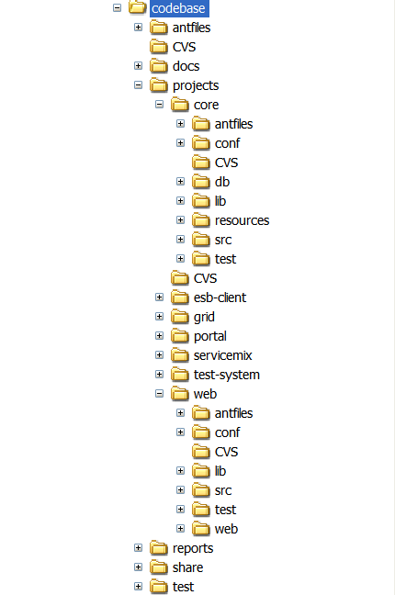
- 3  3 | Verify that the environment variables ANT_HOME and JAVA_HOME, CATALINA_HOME are set and that your PATH statement includes the locations of the Ant and Java binaries. For example., PATH should include C:\apache-ant-1.6.2\bin; C:\j2sdk1.5.0_11\bin.  To do this in Windows:  - Select My Computer > Properties (from the shortcut menu) > Advanced tab.  - Click the Environment_Variables button.  - In the New User Variable dialog box, add the Variable and Variable Value.
Examples:
Variable = ANT_HOME; Variable Value = C:\apache-ant-1.6.2
Variable = JAVA_HOME; Variable Value = C:\j2sdk1.5.0_11
Variable = CATALINA_HOME; Variable Value = C:\apache-tomcat-5.5.20
To do this in Unix:
$ export ANT_HOME=/usr/ant-1.6.2
$ export JAVA_HOME=/usr/java..1.5
$ export CATALINA_HOME =/usr/apache-tomcat-5.5.20

Setup Database

Configure data source properties for C3PR
The C3PR example is configured to work with either Oracle 9i/10g or PostGreSQL 8.2, however, you must assign the appropriate values for the database properties in the codebase\projects\core\conf\database.properties file for the application to access the database
Sample contents of this fil:-

Entry | Oracle | PostGreSQL
datasource.url | jdbc:oracle:thin:@localhost:1521:c3pr | jdbc:postgresql://localhost:5432/c3pr
datasource.username | Enter username | Enter username
datasource.password | Enter password | Enter password
datasource.schema | (optional), by default it connects to the schema same as username | (optional)
datasource.dialect | org.hibernate.dialect.Oracle9Dialect | org.hibernate.dialect.PostgreSQLDialect
datasource.driver | oracle.jdbc.OracleDriver | org.postgresql.Driver

Create Tables
Once a user id with privileges to create tables is created, run the following script to create tables in the schema

For Oracle
codebase\projects\core\db\oracle\c3pr_ddl.sql

For PostGreSQL
codebase\projects\core\db\PostGreSQL\c3pr_ddl.sql

Check for the following Tables created once the above scripts are run with no errors.

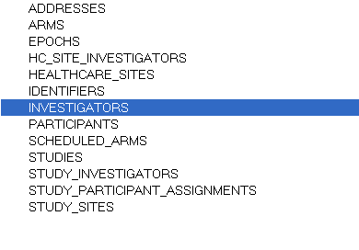

Populate Static Data / Dummy Data
C3PR Application needs a predefined static data (like healthcare sites, addresses), for this the following static-data script must be run. For a head start in testing C3PR Application, sample data might be needed at times (like default study, study design, assignments, participant info and a sample registration). For this dummy-data.sql must be run. (Note that dummy-data includes static data)

For Oracle
codebase\projects\core\db\oracle\static-data.sql
OR
codebase\projects\core\db\oracle\dummy-data.sql

For PostGreSQL
codebase\projects\core\db\PostGreSQL\static-data.sql
OR
codebase\projects\core\db\oracle\dummy-data.sql

Build / Deploy Code (Ant)
Perform the following steps to build your system.

Step | Action
1 | Open command prompt, change directory to codebase\antfiles  (Note – You can also use your your IDE’s built in Ant tool and skip the above test)
2 | Run the following ant task by executing the following command  Ant deploy-webapp

Ant messages display as each task is processing. The build-webapp task builds the core and web projects and deploys the software to the webapp directory of the web application server installation specified in the datasource.properties file.
The below figure illustrates the directory structure resulting from running the deploy-webapp task. This task accomplishes many tasks including generating and compiling the all the source files, deploying the files to CATALINA_HOME\webapps\c3pr directory
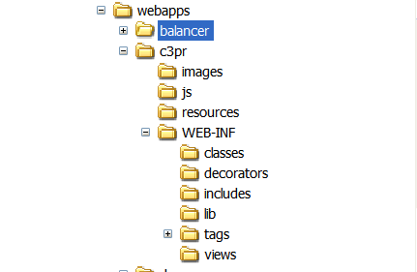

NOTE: | The default ant task build-all should be used with care. By default it is recommended not to use Globus/ESB/ServiceMix for testing basic Web applications. By running build-all, it attempts to build all the projects and might fail if the corresponding installations do not exist.  Refer this section for more details

Setup Web Server, Configuration
Make sure CATALINA_HOME environment variable as described in the previous sections.

Configure log4j
Update the logging info by modifying the following properties in
<CATALINA_HOME>\webapps\c3pr\WEB-INF\log4j.properties

log4j.appender.logfile.File=<CATALINA_HOME>/logs/c3pr.log
Use other log4j properties for debug/info as desired

Configure Dorian / Web SSO configuration
Set the Identity Provider Information, Identity Federation Service URLs in this file
<CATALINA_HOME>\webapps\c3pr\WEB-INF\applicationContext-web-sso.xml
Sample Settings maybe
<property name="idpUrl" value="https://localhost:8446/wsrf/services/cagrid/AuthenticationService"/>
<property name="ifsUrl" value="https://localhost:8443/wsrf/services/cagrid/Dorian"/>

 | BEFORE YOU BEGIN | For the below configurations, namely ESB Broadcast, ESB ConnectionFactory and Globus, It is recommended to set the ESB Broadcast to false if basic testing of C3PR is only desired, setting this to true makes it mandatory to install Service Mix, copy Globus certificates and build all projects in C3PR, detailed instructions of which is not included at this time.

Configure ESB Broadcast feature
ESB is used to broadcast messages from C3PR to other systems like Adverse Events Reporting System, Patient Study Calendar etc. Sometimes in development, testing environment it is necessary to have a feature to enable/disable this feature on demand. This can be set by updating the file

<CATALINA_HOME>\webapps\c3pr\WEB-INF\c3pr-servlet.xml

<property name="isBroadcastEnable" value="false" />

Configure ESB connection factory
If ServiceMix, Logic Fuse is installed and esb broadcast feature is desired, update the Active MQ Connection Factory settings in this file

<CATALINA_HOME>\webapps\c3pr\WEB-INF\applicationContext-esb.xml

<bean id="connectionFactory"
class="org.apache.activemq.ActiveMQConnectionFactory">
<property name="brokerURL" value="tcp://localhost:61616" />
</bean>

Configure Globus
Copy Globus certificates into your home directory from the following location of CVS repository
codebase\share\security\.globus
For Windows,
C:\Documents and Settings\<user-name>
For Unix,
/usr/home

Running C3PR
Perform the following steps to run the system
Step | Action
1 | Open command prompt, change directory to <CATALINA_HOME>\bin
2 | Run the following command to start tomcat server  Catalina.bat
3 | After your web application server has completely finished starting, open Internet explorer 6 with the following URL  http://localhost:8080/c3pr  C3PR home page should be displayed

The following figure displays the browser window that opens with a successful system test.

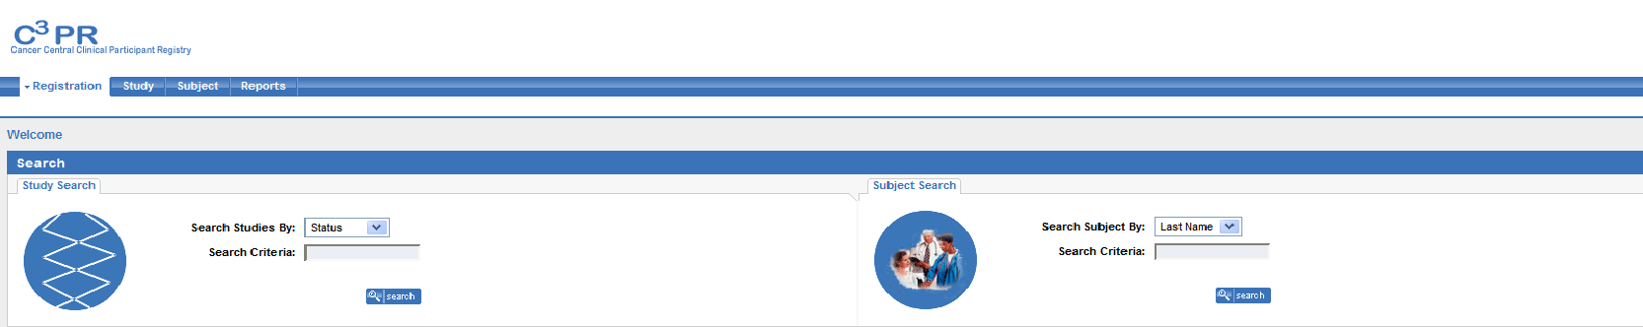

Summary of C3PR Components
C3PR Installation procedure includes the following components:
  - Source Code from gForge/cvs repository
  - Configuration files to enable you to customize your installation to meet your specific database, server, and other network needs
- database.properties
- applicationContext-esb.xml
- applicationContext-web-sso.xml
- c3pr-servlet.xml
  - DDL for creating tables in default schema (“C3PR”) – c3pr_ddl.sql
  - Static data / Dummy for populating sample data contents into schema – static-data.sql/ dummy-data.sql
  - Ant build file – build.xml

Contacting Technical Support
Please mail c3prv2-support@gforge.nci.nih.gov for support on Installation or general C3PR technical Support queries

